**Mobile Application Report — Meme Saver App**

**1. Real World Problem Identification**

In today’s world, memes are one of the most common forms of entertainment and expression shared online. However, users often find it difficult to **save their favorite memes** for later viewing or to organize them in one place without using complex social media tools or manually saving images.  
This lack of an easy-to-use meme-saving solution makes it inconvenient to store and view memes efficiently.

**2. Proposed Solution**

The proposed solution is the **Meme Saver App**, a Flutter-based mobile application that allows users to:

* View and browse memes from different sources.
* **Save their favorite memes locally** on the device.
* View their saved memes anytime — even **offline**.
* Delete saved memes when no longer needed.

The app focuses on simplicity, speed, and cross-platform usability, working equally well on Android and iOS.

**3. Responsive User Interfaces**

The Meme Saver app uses **Flutter’s responsive layout system**, ensuring proper scaling and display on different screen sizes and devices (phones and tablets).  
All UI components adjust automatically based on device dimensions using widgets like Expanded, GridView, and MediaQuery.

**(Screenshots to attach here)**

* **Home Screen & Meme Viewer Page & Saved Memes List**

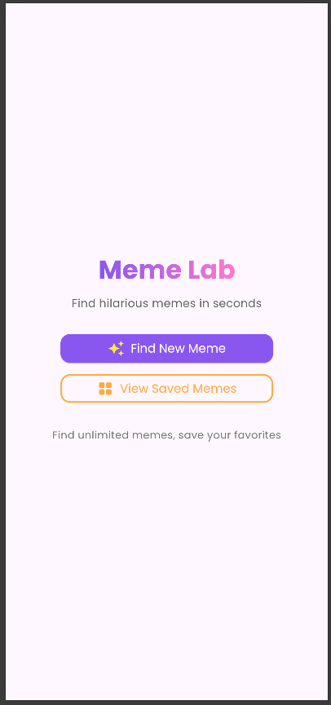

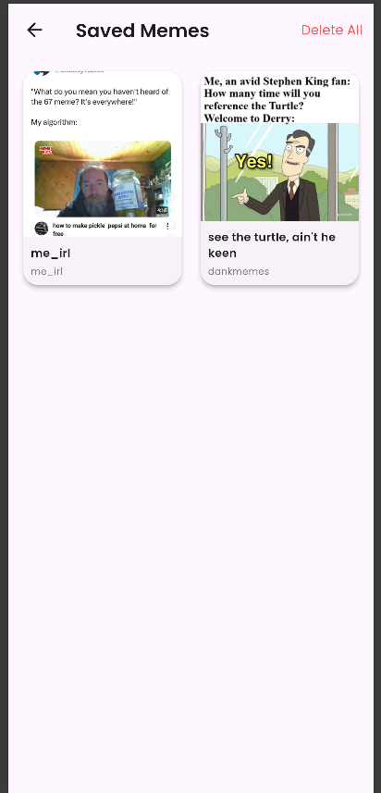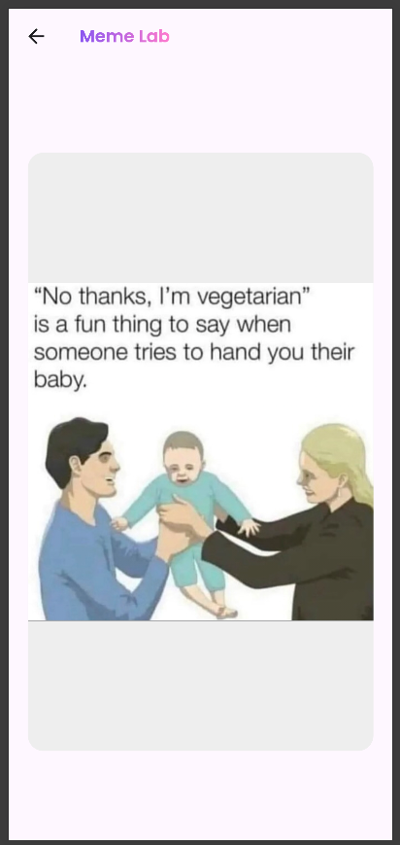

**4. Data Storage**

The app uses **Hive**, a lightweight and high-performance local database for Flutter.

**Justification for using Hive:**

* Works fully **offline** (no internet required).
* Extremely **fast** and optimized for Flutter.
* **Easy to integrate** and maintain.
* Stores data in binary form, making it memory-efficient.
* Ideal for small- to medium-sized local data storage (like saving memes).

Hive stores memes as serialized objects of the SavedMeme model, ensuring persistence across app restarts.

**5. APIs / Packages / Plug-ins (Optional Section)**

The project utilizes several Flutter packages:

| **Package** | **Purpose** | **Justification** |
| --- | --- | --- |
| hive | Local database | To store saved memes persistently and offline |
| hive_flutter | Flutter integration for Hive | To simplify initialization and access in Flutter |
| path_provider | Directory management | Used to find a suitable location for storing Hive data files |

These packages ensure the app remains lightweight yet powerful.

**6. Issues and Bugs Encountered and Resolved**

| **Issue** | **Description** | **Resolution** |
| --- | --- | --- |
| Data not persisting after app restart | Saved memes disappeared after closing the app | Integrated **Hive** for local persistent storage |
| Hive adapter not generating | Errors during build process | Added build_runner and hive_generator as dependencies and fixed file structure |
| Hive “integer key out of range” error | Used invalid integer key for Hive storage | Changed storage logic to use put(key, value) with proper keys |
| Build runner not running | Missing dependency | Installed and ran using dart run build_runner build |
| Import dependency warning | Hive package not recognized | Added Hive to dependencies in pubspec.yaml |

**6. Issues and Bugs Encountered and Resolved**

|  |  |  |  |  |  |  |  |  |  |  |  |  |  |  |  |  |  |  |
| --- | --- | --- | --- | --- | --- | --- | --- | --- | --- | --- | --- | --- | --- | --- | --- | --- | --- | --- |
| | **Issue** | **Description** | **Resolution** | | --- | --- | --- | | **Data not persisting after restart** | Saved memes disappeared when the app was closed and reopened. | Implemented Hive local storage to persist data offline. | | **Hive adapter not generating** | Running build_runner gave an error: “Import directives must precede part directives.” | Fixed file structure by placing part 'saved_meme.g.dart'; after imports and re-ran dart run build_runner build. | | **Build runner command not working** | The old command flutter pub run build_runner build failed. | Used the updated command: dart run build_runner build. | | **Hive initialization error** | Error: “Box not found. Did you forget to call Hive.openBox()?” | Opened the box inside _getBox() method before accessing data. | | **Integer key out of range** | Error: “HiveError: integer key needs to be in range 0–0xffffffff.” | Updated the saving logic to use box.add(meme) instead of manually assigning invalid integer keys. | |

**7. GitHub Repository**

**GitHub Link:**